**Big Mountain Resort Pricing Data**

Traditionally, Big Mountain Resort has simply used the market average price of ski resorts and applied a premium to it. This pricing structure does not take into account resort specific attributes which can make certain resorts much more attractive and, therefore, worth a significantly higher ticket price. After analyzing ski resort market pricing and incorporating these attributes, we have found that our pricing

Initial data exploration shows a correlation between the number of runs, fast quad lift chairs as well as the amount of acreage of snow making. This is seen in the heatmap below.

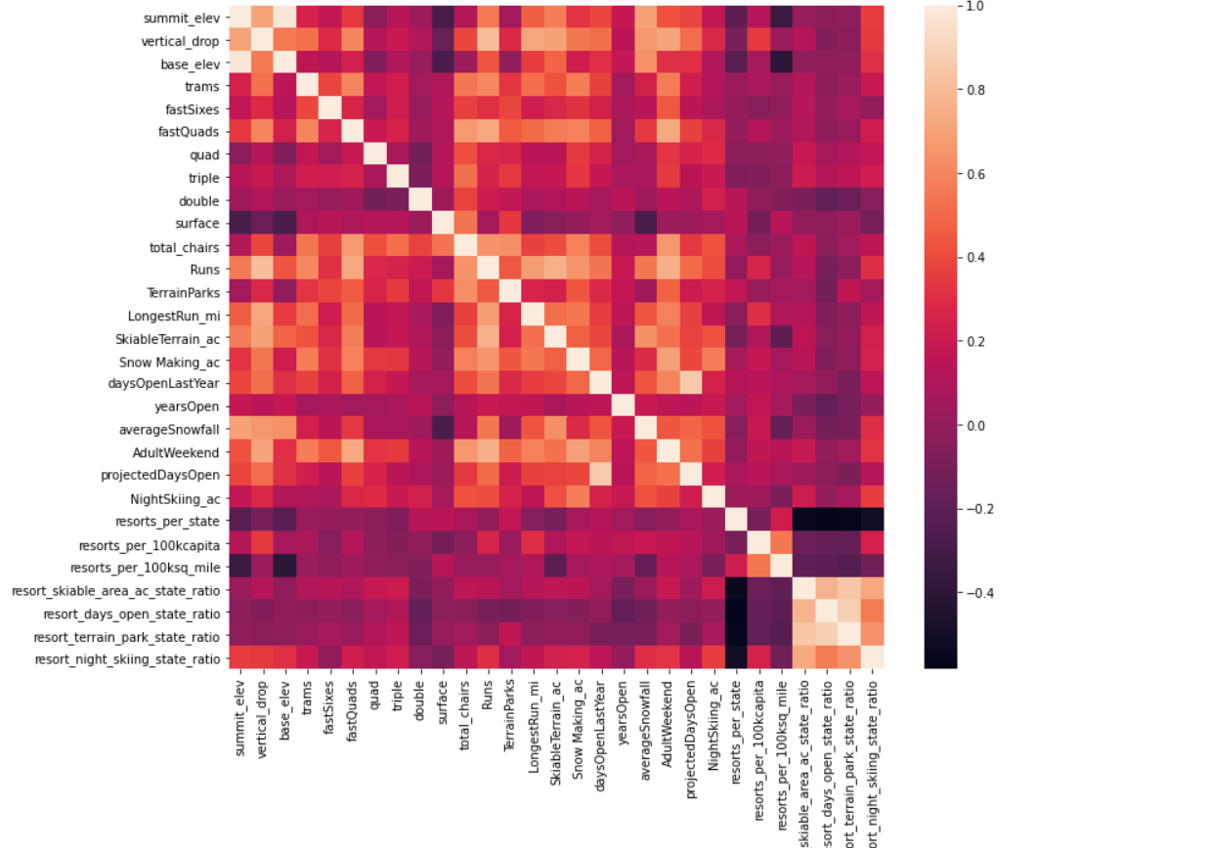

We explored a few different options for modeling ticket price using the data we have. We found that a random forest model provided the best performance, using 8 parameters. This model was able to predict our test data pricing within close to $1 of the real price. Along with the parameters already mentioned, vertical drop was also found to have a significant influence on the expected ticket price charged.

We are currently charging a ticket price of $81. According to our model, there are many factors, that we have discovered to be influential on price, which Big Mountain excels in. Our model suggests that we should be charging a ticket price that is closer to $95.

In terms of possible cost cutting, the data suggests that if we closed one of the runs to reduce costs, this would have no effect on the expected ticket price. This is shown in the figure below:

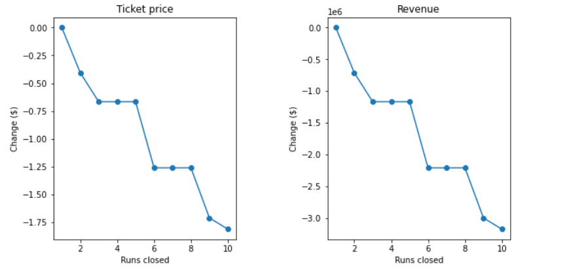

If we were to add increase our vertical drop by 150 ft and install another chair lift, these improvements would allow us to increase our ticket price by $1.99 each. For one season, this would increase our revenue by $3,474,638.